Rajiv Sharma 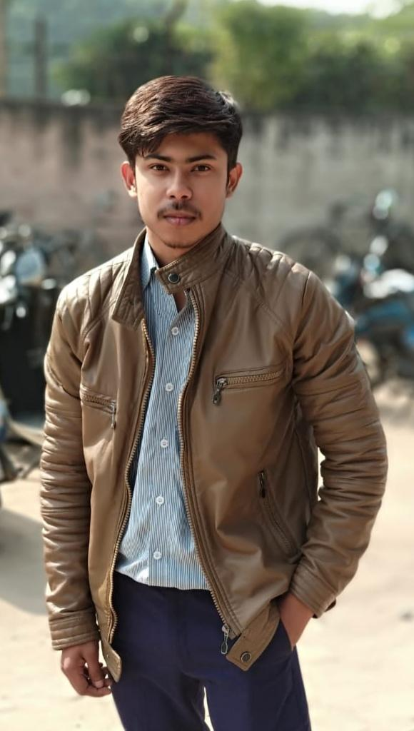

To work for an organization which provides me the opportunity to improve my skills and knowledge to growth along with the organization objective and also seeking a challenging position so as to utilize my skills for organization and individual growth. Extremely passionate about development.

.com/in/shubham-kumar-69b60818

Mail Icon PNG Image - PurePNG | Free transparent CC0 PNG Image Library[anuragsh1812@gmail.com](mailto:anuragsh1812@gmail.com) Phone Cell Icon Vector Illustration 421107 Vector Art at Vecteezy 7834824080

https://tse2.mm.bing.net/th?id=OIP.H1sst0o9TufttxJdoHM_eQHaHa&pid=Api&P=0&w=300&h=300 ***Ghaziabad, India.*** https://tse4.mm.bing.net/th?id=OIP.cifjoWlUs15Sncv3YzwUrQHaHa&pid=Api&P=0&w=300&h=300 ***(self created***) <https://rajivsh1812.github.io/portfolio/>

***EDUCATION****.com/Shubham10-03*

**Graduation**

Babu Banarasi Das Institute of Technology, Ghaziabad

*08/2017 - 07/2021*,

*Courses*

B.Tech with EEE with

aggregate of 77%

**Intermediate**

National Public Senior Secondary School,Randera Nagar

*04/2016 - 06/2017*, *Ghaziabad*

**Matriculation**

National Public Senior Secondary School, Shahibabad *06/1993 - 07/1994*, *Ghaziabad*

**PERSONAL PROJECTS**

Designed own Portfolio with the help of HTML, CSS and JS and some minor projects with c and java.

**WORK EXPERIENCE**

**Training in Sofcon for automation 2020**

Programmable logic control and Scada.

*06/2020 - 09/2020*.

**Training in CEC 2019**

C language.

*08/2019-10/2019.*

**ACHIEVEMENT**

Participated in E-Yantra robotics Competition

(09/2019 - 09/2019)

Team Member of volleyball team of our class.

**TEAM MEMBERSHIP ROLES**

Team Leader of Organization Committee of Freshers for Juniors (08/2018 - 09/2018)

*Organized Fresher's Party For Juniors*

Team member Of College's Elecon Society (08/2019 - Present) *I was Team member of Elecon Society Of College . we have Organized many Technical as well as Quiz Competitions inside the college.*

**SOFT SKILLS**

Positive Thinker

Active Listener

Willingness to learn new things

Adaptability

Good Communication Skills and Disciplined.

**LANGUAGE**

English

Full professional proficiency

Hindi

Full professional proficiency

**INTEREST**

Coding and space.

**Skill**

Java,HTML,C,CSS.